VG11:

04/07/2021 – Tested with batch size of 48 and for 20 epochs

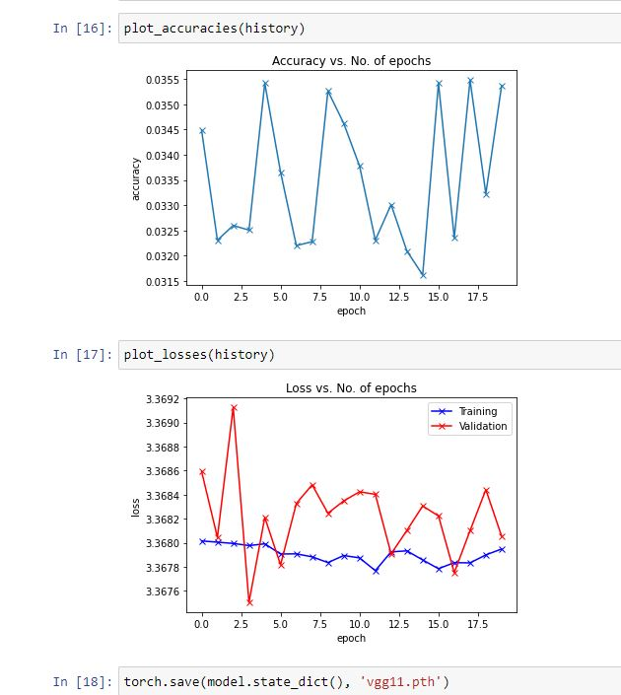

10/07/2021 – Ran into Syntax error with **VGG16**

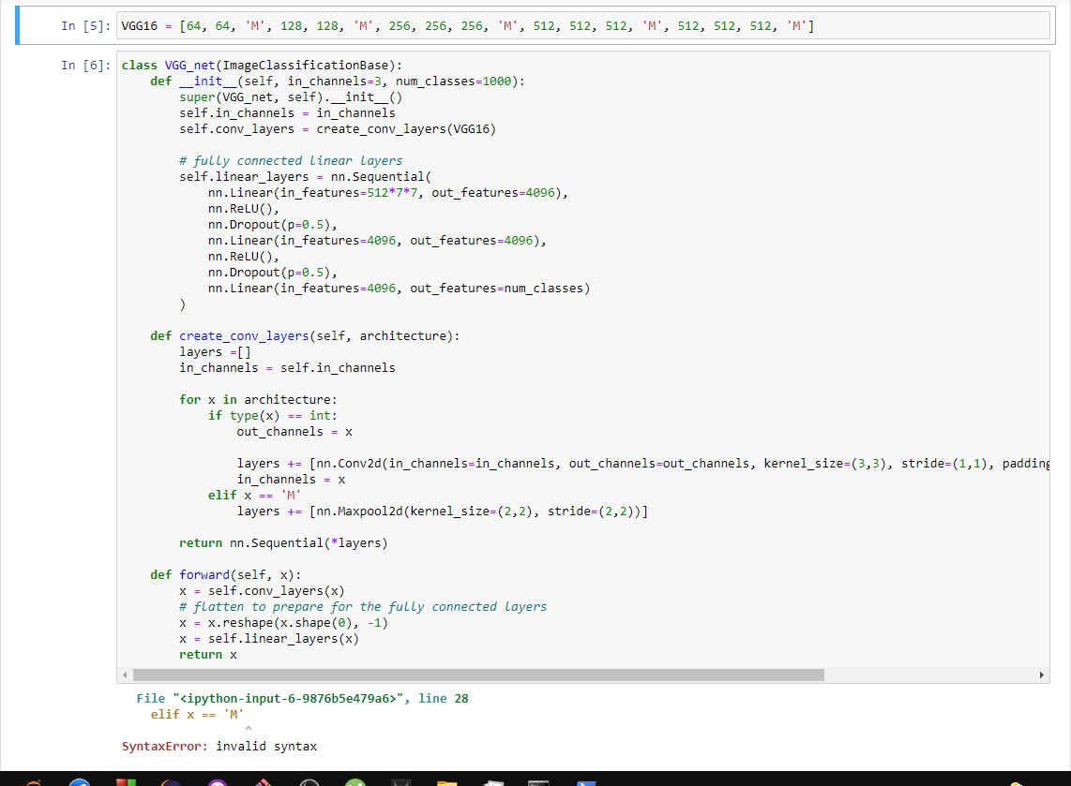

10/07/2021 – Successfully Ran ResNet 18 with 99% accuracy

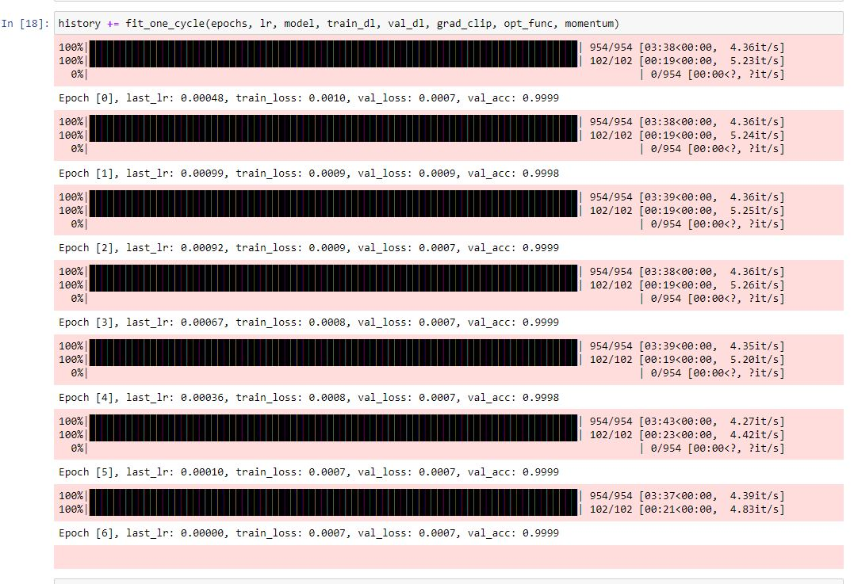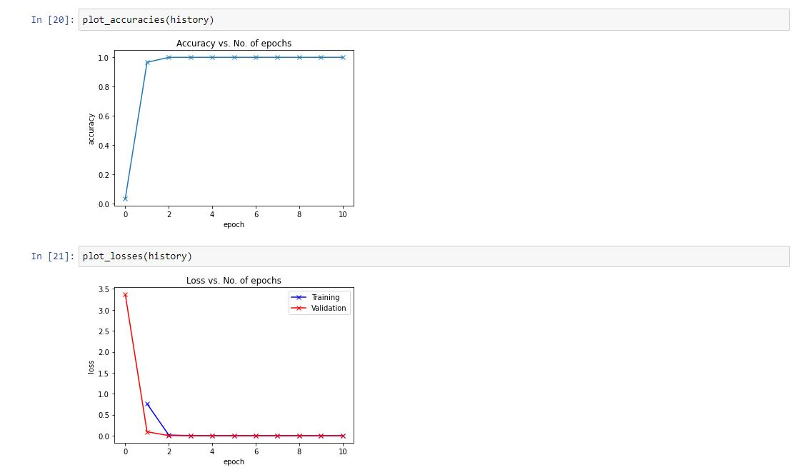

10/07/2021 – Ran into more errors in VGG 16, there were mainly syntax errors and were fixed as soon as they were found.

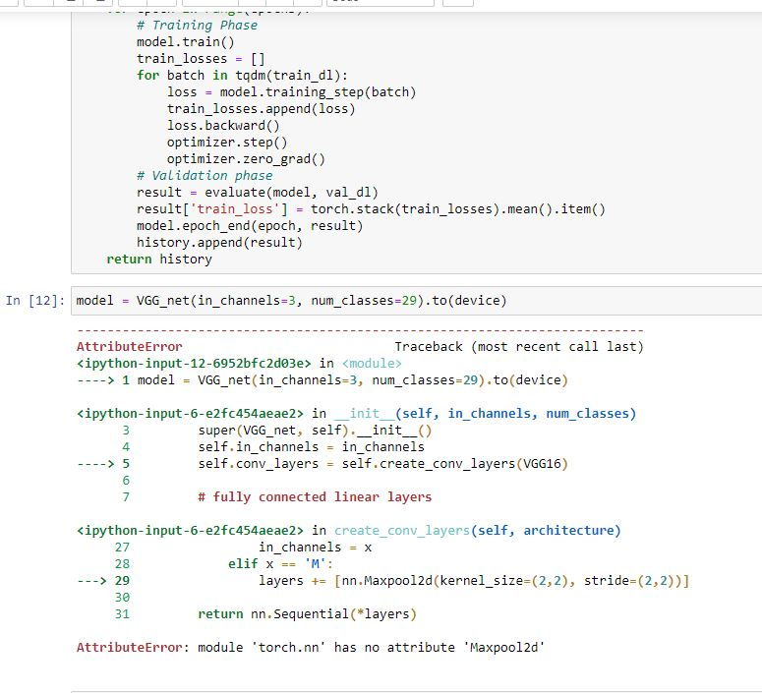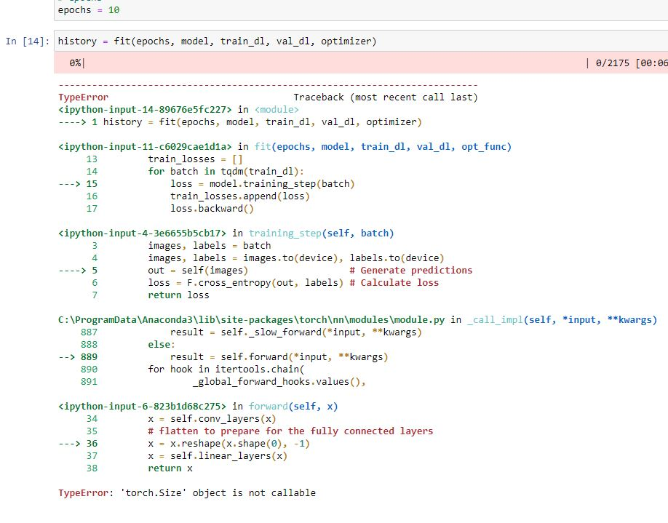

10/07/2021 – GPU Memory Size was exceeded for VGG 16 with batch size of 32, had to decrease to 16 to resolve this issue.

10/07/2021 – Fixed all problems and found these results for VGG16 for ASL.

